**CNIT 315 Final Project**

Rahul Kumar

Lakshya Garg

Mitchell Lee

Lucas Hennessy

Jacob Carlson

**Conway’s Game Of Life - Project Description**

**What is Game of Life?**

The Game of Life, also known simply as Life, is a cellular automaton devised by the British mathematician John Horton Conway in 1970. The "game" is a zero-player game, meaning that its evolution is determined by its initial state, requiring no further input. One interacts with the Game of Life by creating an initial configuration and observing how it evolves or, for advanced players, by creating patterns with particular properties.

**Rules:**

The universe of the Game of Life is an infinite two-dimensional orthogonal grid of square cells, each of which is in one of two possible states, alive or dead. Every cell interacts with its eight neighbours, which are the cells that are horizontally, vertically, or diagonally adjacent. At each step in time, the following transitions occur: ·

* Any live cell with fewer than two live neighbours dies. ·
* Any live cell with two or three live neighbours lives on to the next generation. ·
* Any live cell with more than three live neighbours dies. ·
* Any dead cell with exactly three live neighbours becomes a live cell.

These rules continue to be applied repeatedly to create further generations.

**Project Timeline:**

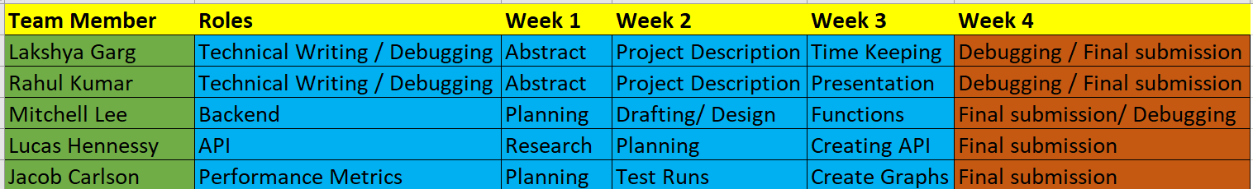

**The Prototype:**

* The program is a command line interface
* It displays the Game of life through a grid of ASCII characters
  + “.” == off
  + “*” == “on”
* The program uses some user input
* Upon starting the program, the command line will ask the user to input:
* Number of iterations
* NUmber of starting positions
* The program will ping an API for the random starting positions received by the user. The positions will be stored in a linked list with one position (two random numbers) per node.
* The program will iterate over the linked list to initialize the two matrices turning cells at the random starting positions on (1).
* The program will make use of two 10x10 multidimensional arrays represent the alive and dead cells
* One multidimensional array representing the grid in the previous time step will be run through the game of life function
* The function will then change each corresponding member in the other multidimensional matrix which represents the grid in the next time step.
* The print function will then print a grid representing the values in the current matrix.
* Previous matrix will then be set to the current matrix
* This process repeats itself equal the number of iterations set by the user.
* User will be given option to go back to the menu or exit at the end of each game.

**API Usage:**

* **-**Random.org
* **-** [**https://www.random.org/clients/http/**](https://www.random.org/clients/http/)
* True random using atmospheric noise
* **-**Pulling a number of starting positions x2
* **-** 30-99 positions x2 = 60-198 integers
* Each random number ranges from 0-9
* Numbers Stored in a linked list
  + Two random number per node (x,y)
* **-** Starting positions = black squares

**Backend Logic:**

* **-**Dynamic data structure - linked lists
  + 2 integers per node (x,y)
* **-**Allows transition from node to node